1. create token as below

3923261edad346fd87f0773dda007e7879421008

2. git clone the repository under public_html directory

3. turn on password caching with GitHub on the server

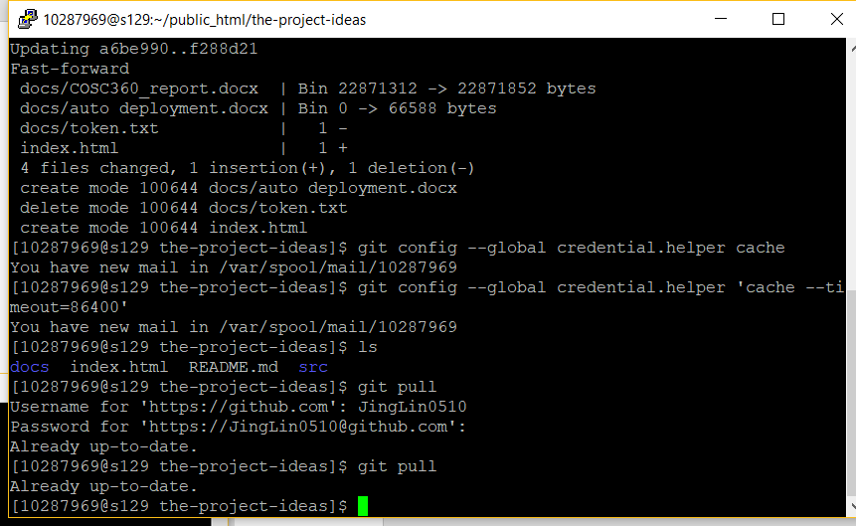

4. setup crontab to pull changes

